**Welcome to the 2016 Evergreen Women’s Golf Association (EWGA) Visitation**

**Mt. Angel, Oregon - Tuesday July 12th**

Entry fee of $45.00 includes 9 holes of Golf and Lunch. Fee and sign up must be post marked by **6/30/16** in order to be accepted into play. Carts are $6.00/person and you will be paired with another player who is using a cart. You must have a USGA GHIN number to play. We are sorry, but due to all the paperwork and pairing necessary we cannot accept late enrollment.

8:00 A.M. Continental Breakfast and Registration

9:00 A.M. Shot Gun Start

**Make checks payable to EWGA and mail application to: Mary Beth Holt , PO** B**ox 515, Mt. Angel, OR 97362**

|  |  |  |  |  |  |
| --- | --- | --- | --- | --- | --- |
|  | Print Name | Club | USGA GHIN# | Cart? | Paid – Cash/Check |
| 1 |  |  |  |  |  |
| 2 |  |  |  |  |  |
| 3 |  |  |  |  |  |
| 4 |  |  |  |  |  |
| 5 |  |  |  |  |  |
| 6 |  |  |  |  |  |
| 7 |  |  |  |  |  |
| 8 |  |  |  |  |  |
| 9 |  |  |  |  |  |
| 10 |  |  |  |  |  |
| 11 |  |  |  |  |  |
| 12 |  |  |  |  |  |
| 13 |  |  |  |  |  |
| 14 |  |  |  |  |  |
|  |  |  |  |  |  |
|  |  |  |  |  |  |
|  |  |  |  |  |  |

**Your President’s/Captain’s email for future use ____________________________________________

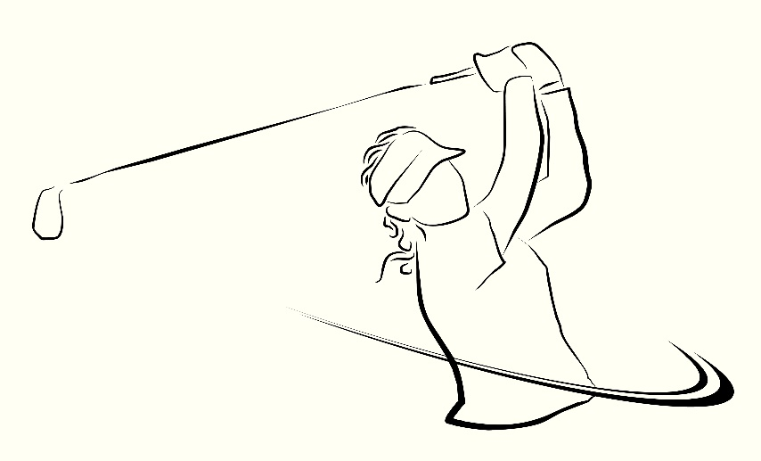Any Questions please contact-Mary Beth Holt 503-845-2178, or Sherry Carlson 503-709-2921

**“Have a Swinging Good Time”**